**Install Cucumber Eclipse Plug in.**

1. Cucumber eclipse plug in can be downloaded from the **Eclipse Market place** directly, by searching for cucumber.

**OR**

1) Launch the *Eclipse IDE* and from Help menu, click “***Install New Software***”.

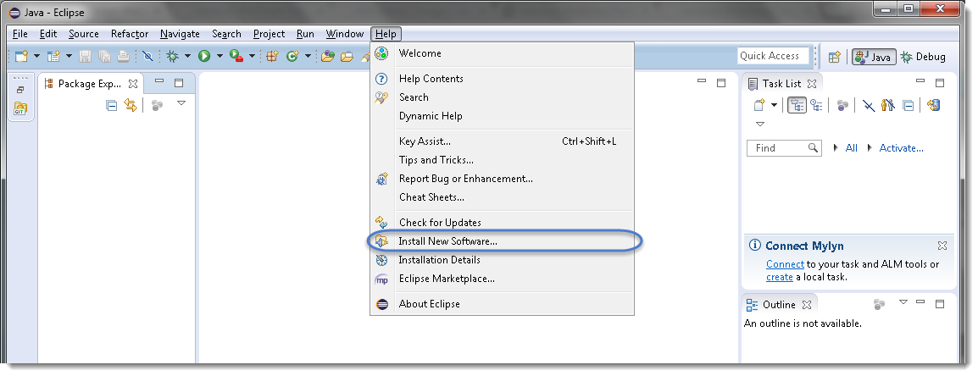

2) You will see a dialog window, click “***Add***” button.

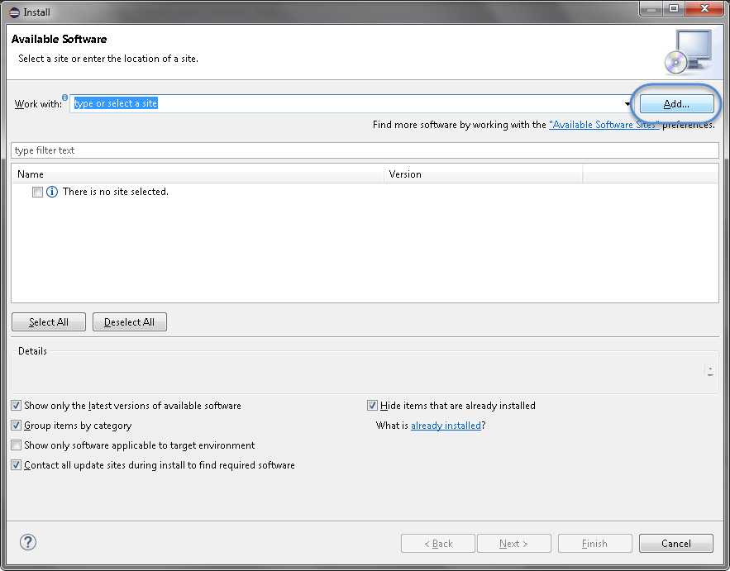

3) Type name as you wish, let’s take “***Cucumber***” and type “***http://cucumber.github.com/cucumber-eclipse/update-site***” as location. Click ***OK***.

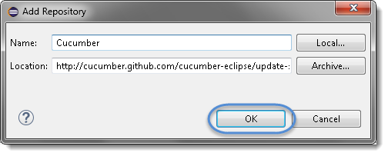

4) You come back to the previous window but this time you must see ***Cucumber Eclipse Plugin*** option in the available software list. Just ***Check*** the box and press “***Next***” button.

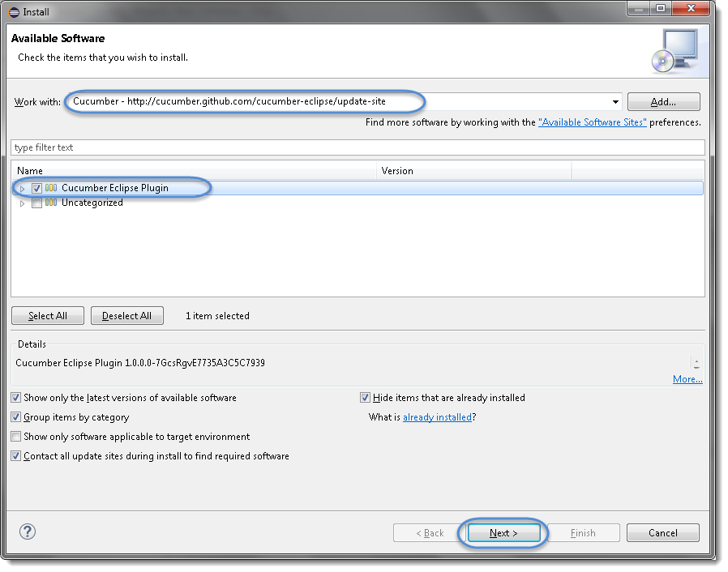

5) Click on ***Next***.

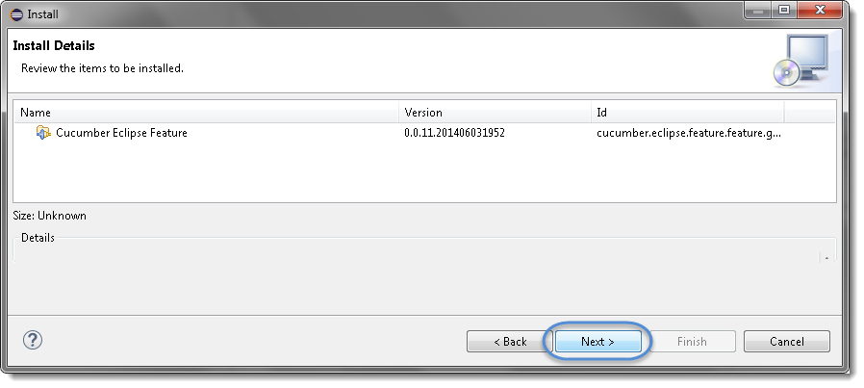

6) Click “***I accept the terms of the license agreement***” then click ***Finish***.

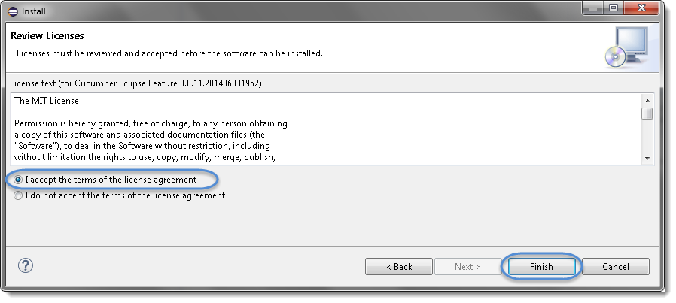

7) Let it install, it will take few seconds to complete.

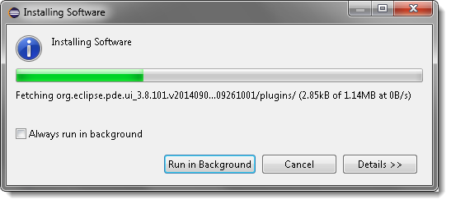

8) You may or may not encounter a Security warning, if in case you do just click ***OK***.



9) You are all done now, just Click **Yes**.

